**Jamk Library Srs**

**Stakeholders**

**Primary Stakeholders:**

* **JAMK Library Management**: Oversees the project and ensures it meets the library’s requirements.
* **JAMK Students and Staff**: End-users who will use the system to borrow, reserve, and extend loans.
* **JAMK IT Department**: Ensures integration with the existing JAMK authentication system.
* **BeSoft Ltd**: The development company responsible for designing, developing, and maintaining the system.
* **JAMK Administration**: Ensures the system aligns with JAMK policies and regulations.

**Secondary Stakeholders:**

* **Cybersecurity Experts**: Ensures that user data remains secure.
* **Regulatory Authorities**: Ensures compliance with data protection laws.
* **External Vendors (E-Book Providers)**: Integration partners for e-book lending.

**Feasibility Study**

**Technical Feasibility:**

* The system will be a web-based platform, ensuring accessibility from any device.
* JAMK’s authentication system will be integrated using industry-standard authentication protocols.
* Modern web frameworks will be used to ensure responsiveness and security.

**Economic Feasibility:**

* The approved budget is 300k€.
* Development costs include frontend, backend, security, and infrastructure setup.
* Maintenance and potential scalability costs are considered.

**Operational Feasibility:**

* Users are already familiar with digital systems, so the learning curve will be minimal.
* A user-friendly interface will be designed for easy access and navigation.
* Support and training will be provided for staff.

**Legal Feasibility:**

* Compliance with GDPR and JAMK’s internal policies regarding data protection.
* Agreements with e-book providers for content distribution.

**Software Requirements Specification (SRS)**

**1. Introduction**

**1.1 Purpose**

The purpose of this document is to define the requirements for a modern, secure, and efficient book loan system for JAMK Library, including e-book lending capabilities.

**1.2 Conventions**

* The system will follow ISO/IEC 25010:2011 software quality standards.
* Security best practices such as OWASP Top 10 will be adhered to.

**1.3 Intended Audience**

* JAMK Library Management
* BeSoft Ltd development team
* JAMK IT Department
* Security and Compliance teams

**1.4 Scope**

* Users can borrow, reserve, and extend book loans.
* E-book borrowing capability is included.
* Secure authentication using JAMK credentials.
* Web-based system with mobile-friendly design.
* Secure storage of user data.

**1.5 References**

* JAMK IT Security Policies
* GDPR Regulations

**2. Overall Description**

**2.1 Product Perspective**

The new system replaces the existing manual book loan tracking process, integrating with JAMK’s authentication system and ensuring security and ease of use.

**2.2 Product Features**

* Secure user authentication.
* Physical book borrowing, reserving, and extending.
* E-book lending.
* Mobile-friendly interface.
* Administrative dashboard for staff.

**2.3 Operating Environment**

* Web-based application.
* Compatible with modern browsers.
* Mobile and desktop usability.

**2.4 Design and Implementation Constraints**

* Must integrate with JAMK authentication systems.
* Must comply with GDPR.
* Budget limitation of 300k€.

**2.5 User Documentation**

* User guides and FAQs.
* Staff training materials.

**2.6 Dependencies**

* JAMK authentication system.
* Third-party e-book providers.
* Web hosting and database infrastructure.

**3. System Features**

**3.1 Functional Requirements**

* Users must authenticate using JAMK credentials.
* Users can borrow books (physical and digital).
* Users can reserve books.
* Users can extend loan periods.
* Admins can manage inventory and users.

**3.2 System Requirements**

* Web-based application.
* Secure database for storing user and book data.
* Integration with JAMK authentication.
* Scalability to handle hundreds of simultaneous users.

**Use Case Diagram**

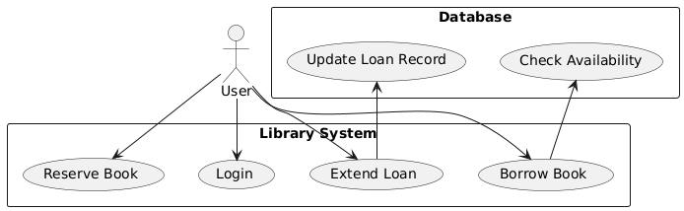

**Sequence Diagram**

